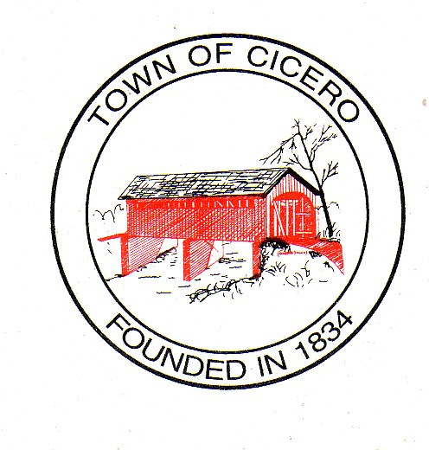
4 TOWN OF CICERO
TOWN COUNCIL MEETING MINUTES
December 1, 2015

At 7:00 PM

Call To Order: President Kay Hartley called the meeting to order and led the Pledge of Allegiance. Dennis Schrumpf gave the prayer. President Hartley called for the roll call and the members of the Town Council were present or absent as follows:

Present: Kay Hartley Absent: Eric Hayden
Brett Foster
Chad Amos
Dennis Schrumpf

President Hartley declared a quorum present.

Others Present: Jan Unger, Clerk Treasurer
Charlie Cambre, Park SXuperintendent
Pat Comer, Street & Utilities Director
Dave Hildebrand, Police Chief
Lance Overholser, Assistant Fire Chief
Paul Munoz, Cicero/Jackson Township Plan Commission Director
John Culp, Town Attorney
Keith Bryant, Town Engineer

Approval of Agenda:
Mr. Amos made a motion to approve the agenda. Mr. Foster seconded, motion passed.

Approval of Prior Minutes:
Town Council Meeting Minutes, November 17, 2015, 7:00 PM - Mr. Foster made a motion to approve the Town Council Meeting Minutes, December 1, 2015. Mr. Amos seconded, motion passed.
Cicero Town Council Executive Session Memorandum, November 23, 2015, 7:00 PM – Mr. Amos made a motion to approve the Cicero Town Council Executive Session Memorandum, November 23, 2015. Mr. Foster seconded, motion passed.

Approval of Claims:
Mr. Schrumpf made a motion to approve the claims as presented. Mr. Foster seconded, motion passed.
Petitions by Citizens:
There were none.
President’s Report:
- President Hartley distributed annual holiday cards for employees to the department heads.
Council Committee Reports:
- Event Committee –Nothing this evening.
Legal Counsel Report-Aaron Culp
Mr. Culp stated that he had nothing.
Cicero/Jackson Township Plan Commission Report:

Mr. Munoz informed the Council that he has hired an Administrative Assistant.

Town Engineer Report-Mr. Keith Bryant:
Mr. Bryant reported on the following:
- UV Filter system at Wastewater Plant – Mr. Bryant stated that United was reviewing the bill. Thieneman said they would be starting on November 23rd and work three days that week and then back on November 30th and continue through completion.
- Brinton Street – Mr. Bryant stated that the curbs were completed on Brinton Street and he has e-mailed Midwest to notify them that the work was to be completed by this Friday and inquired when they thought they would be done. Midwest will then finish the drive in Hidden Bay and then move to Main Street.
- Update on Hidden Bay – The Contract is done and this project should be closing soon.
- SR 19 – Mr. Bryant will revise the plans for this project to include the curbing and ramps and then they will need to get an updated permit from INDOT. The cost for United will be no more than $900. Mr. Foster made a motion to approve the $900 expenditure. Mr. Schrumpf seconded, motion passed.
- Bill from INDOT for $6,206.00 – Mr. Bryant explained that this was a change order for the GIF receptacles on the light poles across the causeway. INDOT would not pay and the Town Council agreed to pay this change order but INDOT inadvertently paid the bill. They are now cleaning up their paperwork and found that the Town owes this. Mr. Bryant asked Ms. Unger to make sure that we have not already paid 20% of this bill.

Old Business:

New Business

Council To Consider The Town’s Contract With The Hamilton Heights Amateur Sports Association.
Mr. Foster informed the Council that he has talked with Brian Swart with the Hamilton Heights Amateur Sports Association (HHASA) and the contract will be the same for 2016 as it was for 2015 with Council approval. Mr. Amos inquired about the possibility of the Association installing lighting. Mr. Swart stated that it was a pipe dream at this point. Mr. Swart stated that they are considering batting cages and are working with Mr. Cambre on the location. Mr. Foster made a motion to approve the 2016 Contract for $1,000 with HHASA with the updating of the dates and to approve Ms. Hartley to sign. Mr. Schrumpf seconded, motion passed.

Council To Consider Resolution 11-17-2015-1 Transfers For Plan, Fire, Police, and Park.
Mr. Amos made a motion to approve Resolution 11-17-2015-1 Transfers for Plan, Fire, Police, and Park. Mr. Schrumpf seconded, motion passed.

Council To Consider Ordinance 11-17-2015-2 An Ordinance Establishing The Operating Budgets For Water Company and Wastewater Treatment Company For The Year 2016.
Mr. Amos made a motion to approve Ordinance 11-17-2015-2 An Ordinance Establishing The Operating Budgets For Water Company and Wastewater Treatment Company For The Year 2016. Mr. Foster seconded, motion passed.

Miscellaneous
There was none.

Comments By Citizens
There was none.

Signatures on Official Documents!

Motion To Adjourn:

Mr. Foster made a motion to adjourn. Mr. Amos seconded, motion passed.

Signatures of Cicero Town Council:

__________________________
Sylvia Kay Hartley - President

__________________________
Brett S. Foster - Vice-President

__________________________
Chad B. Amos

__________________________

Eric C. Hayden

_______________________
Dennis D. Schrumpf

Attested: __________________________
Jan Unger, Clerk Treasurer

The next Cicero Town Council Meeting will be on December 1, 2015, at 7:00 PM at the Cicero Town Hall.

