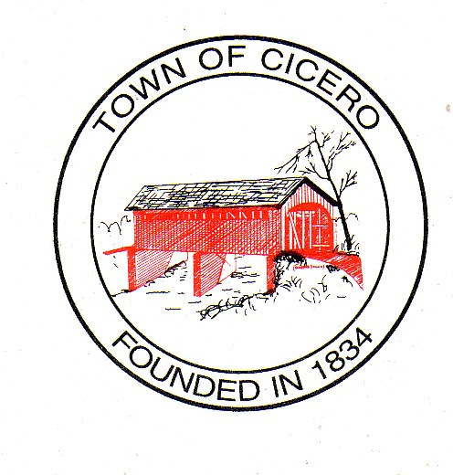
4 TOWN OF CICERO
TOWN COUNCIL MEETING MINUTES
December 1, 2015

At 7:00 PM

Call To Order: President Kay Hartley called the meeting to order and led the Pledge of Allegiance. Dennis Schrumpf gave the prayer. President Hartley called for the roll call and the members of the Town Council were present or absent as follows:

Present: Kay Hartley Absent: Eric Hayden
Brett Foster
Chad Amos
Dennis Schrumpf

President Hartley declared a quorum present.

Others Present: Jan Unger, Clerk Treasurer
Charlie Cambre, Park Superintendent
Pat Comer, Street & Utilities Director
Dave Hildebrand, Police Chief
Lance Overholser, Interim Fire Chief
Paul Munoz, Cicero/Jackson Township Plan Commission Director
John Culp, Town Attorney
Keith Bryant, Town Engineer

Approval of Agenda:
Mr. Amos made a motion to approve the agenda. Mr. Foster seconded, motion passed.

Approval of Prior Minutes:
Town Council Meeting Minutes, November 17, 2015, 7:00 PM – Mr. Foster made a motion to approve the Town Council Meeting Minutes, November 17th, 2015. Mr. Amos seconded, motion passed.
Cicero Town Council Executive Session Memorandum, November 23, 2015, 7:00 PM – Mr. Amos made a motion to approve the Cicero Town Council Executive Session Memorandum, November 23, 2015. Mr. Foster seconded, motion passed.

Approval of Claims:
Mr. Schrumpf made a motion to approve the claims as presented. Mr. Amos seconded, motion passed.
Petitions by Citizens:
There were none.
President’s Report:
- Proclamation of Indiana Statehood Day and the Official Kickoff of the Bicentennial – Ms. Hartley read the Proclamation of Indiana Statehood Day and the Official Kickoff of the Bicentennial. December 11, 2015 starts the beginning of the State’s Bicentennial year. Mr. Foster made a motion of affirmation for the Proclamation and to allow Ms. Hartley to sign. Mr. Amos seconded, motion passed. Ms. Unger stated that the Town received a Bicentennial Flag from the State.
- Ms. Hartley stated that the Council has received a notice of Fire Chief Peachey’s resignation which she read. Ms. Hartley thanked Chief Peachey for his 15 years of service as Fire Chief. Mr. Amos made a motion to accept Chief Peachey’s resignation. Mr. Foster seconded, motion passed.
- Ms. Hartley then asked for a motion to appoint an interim fire chief. Mr. Amos made a motion to appoint Assistant Chief Lance Overholser as interim fire chief. Mr. Foster seconded, motion passed.
Council Committee Reports:
- Event Committee –Nothing this evening.
Legal Counsel Report-Aaron Culp
Mr. Culp stated that Aaron Culp was in Evansville presenting at the Newly Elected Officials Training.
Cicero/Jackson Township Plan Commission Report:

Mr. Munoz stated that he had nothing this evening.

Town Engineer Report-Mr. Keith Bryant:
Mr. Bryant reported on the following:
- UV Filter system at Wastewater Plant – Mr. Bryant stated that the contractor has been on site; he will be leaving next week and coming back when the materials have been delivered.
- SR 19 - Mr. Bryant stated that Dorsey has nearly completed the Town’s portion of the sidewalks. They only have the section at Dean Street to complete. Mr. Bryant stated that they have not submitted to INDOT the additional work to be done on SR 19 curbs and ADA ramps. They will be talking to Dorsey to see how they plan to facilitate removing and adding new curbs and ramps so United will be able to discuss with INDOT when they apply for the permit. This will probably not be finished until spring.
- Brinton Street – Mr. Bryant stated the paving was completed and all that is left is the striping which should be done when Midwest completes paving Main Street.
- Update on Hidden Bay – Mostly complete but still have some finish work to do and a punch list. Some of the work may wait until next year. There is an overage on the asphalt and United is requesting justification on this issue. Ms. Freeman with Mendenhall and Associates will discuss further information later.
- Main Street Paving – Mr. Bryant stated that Midwest should be here Thursday and Friday, December 3rd and 4th to pave Main Street.

Old Business:

Mendenhall And Associates To Address Council Concerning The Hidden Bay Water Project.
Ms. Freeman with Mendenhall and Associates stated that pay application #3 for C.A.T. Excavating in the amount of $111,571.00 has been submitted. She stated that there is Change order #1 included which is a deduction of $3,686.00 from their contract. The Town needs to approve this. Mendenhall will make a grant draw claim voucher in the amount of $12,198.00 leaving the retainage amount of $38,780.20 in the grant. The Town needs to write a check to C.A.T. in the amount of $99,370.00. Mr. Schrumpf made a motion to pay the $99,370 on Thursday’s claims and give Ms. Hartley permission to sign documents. Mr. Foster made a motion to approve the Change Order. Mr. Schrumpf seconded, motion passed.
Ms. Freeman stated that there would be one final pay application later. They are waiting on final from United. Mendenhall is working with C.A.T. on the labor standards. Grant will pay the retainage of $38,780.20. Monitoring will begin when closed. Grant needs to be closed in April of 2016.

New Business

Miscellaneous
- Ms. Unger informed the Council that a couple of public notices that she was supposed to publish did not get done when they were scheduled to be. This has been corrected but because of this issue the bonds will not sale on December 3rd as scheduled. However, everything will be completed by December 15th for the Council meeting and the bonds will sale after that and close this year. Ms. Unger stated that she would still like the Council to approve paying the Umbaugh Invoice in the amount of $25,000 as soon as the money is deposited into the Bond account. Mr. Foster made a motion to approve the Invoice for Umbaugh regarding the Bond issue. Mr. Schrumpf seconded, motion passed.

Comments By Citizens
There was none.

Signatures on Official Documents!

Motion To Adjourn:

Mr. Foster made a motion to adjourn. Mr. Schrumpf seconded, motion passed.

Signatures of Cicero Town Council:

__________________________
Sylvia Kay Hartley - President

__________________________
Brett S. Foster - Vice-President

__________________________
Chad B. Amos

__________________________

Eric C. Hayden

_______________________
Dennis D. Schrumpf

Attested: __________________________
Jan Unger, Clerk Treasurer

The next Cicero Town Council Meeting will be on December 15, 2015, at 7:00 PM at the Cicero Town Hall.

