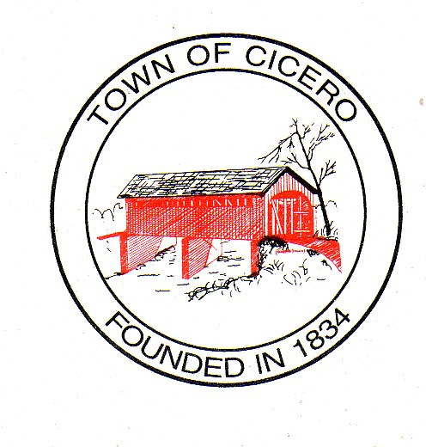
4 TOWN OF CICERO
TOWN COUNCIL MEETING MINUTES
Tuesday, December 28, 2015

At 7:00 PM

Call To Order: President Kay Hartley called the meeting to order and led the Pledge of Allegiance. Brett Foster gave the prayer. President Hartley called for the roll call and the members of the Town Council were present or absent as follows:

Present: Kay Hartley Absent: Eric Hayden
Brett Foster
Chad Amos
Dennis Schrumpf

President Hartley declared a quorum present.

Others Present: Jan Unger, Clerk Treasurer

Approval of Agenda:
Mr. Amos made a motion to approve the agenda as presented. Mr. Foster seconded, motion passed.

Approval of Prior Minutes:
Town Council Meeting Minutes, December 15, 2015, 7:00 PM – Mr. Schrumpf made a motion to approve the December 15, 2015 minutes as presented. Mr. Amos seconded, motion passed.

Approval of Claims:
Mr. Amos made a motion to approve the claims as presented. Mr. Schrumpf seconded, motion passed.

Old Business:

Council To Consider Reimbursement Agreement Between The Indiana Department of Transportation And The Town of Cicero, Indiana Concerning The Costs Of Ramp Installations And Curb Work Along State Road 19 And Giving President To Sign.
Mr. Amos reviewed the agreement and then made a motion to approve and allow Ms. Hartley permission to sign when the final copy is received. Mr. Foster seconded, motion passed.

Miscellaneous
- Ms. Unger noted to the Council for the record the encumbrances for 2016:
GENERAL 10137404 Vehicle Equipment $2,164.00
CCD 239001436 Miscellaneous $35,000.00
MVH 708970391 Paving $48,949.00

Comments By Citizens

Signatures on Official Documents!

Motion To Adjourn:

Mr. Foster made a motion to adjourn. Mr. Schrumpf seconded, motion passed.

Signatures of Cicero Town Council:

__________________________
Chad B. Amos

__________________________
Brett S. Foster

__________________________
Christopher J. Lutz

__________________________

Robert J. Miller

_______________________
Craig S. Penwell

Attested: __________________________
Jan Unger, Clerk Treasurer

The next Cicero Town Council Meeting will be on January 5, 2016, at 7:00 PM at the Cicero Town Hall.

