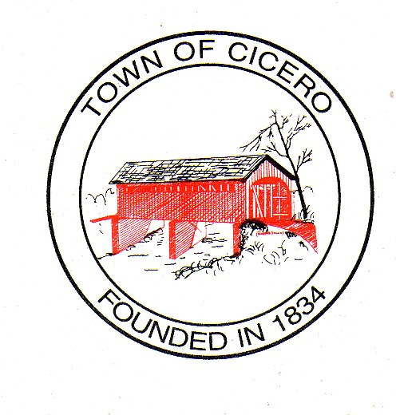
4 TOWN OF CICERO
TOWN COUNCIL MEETING AGENDA
Tuesday, April 19, 2016

At 7:00 PM

Call To Order:

Present: Brett Foster Absent:
Chad Amos
Chris Lutz
Rusty Miller
Craig Penwell

Declare a quorum present.

Others Present: Jan Unger, Clerk Treasurer
Charlie Cambre, Park Superintendent
Pat Comer, Street & Utilities Director
Dave Hildebrand, Police Chief
Lance Overholser, Fire Chief
Paul Munoz, Cicero/Jackson Township Plan Commission Director
Aaron Culp, Town Attorney
Keith Bryant, Town Engineer
Paul Utterback, Storm Water Management Board President

Approval of Agenda:

Presentation: Downtown Revitalization Plan by HWC (Resolution-1st reading)
04-19-2016-1 Resolution Of The Town Council Of The Town of Cicero, Indiana Approving the Downtown Revitalization Plan (Cannot pass this evening, needs one more reading)

Approval of Prior Minutes:
Town Council Special Meeting, March 22, 2016, 7:00 PM -
Town Council Meeting Minutes, April 5, 2016, 7:00 PM -

Approval of Claims:

Petitions by Citizens:

President’s Report:

Council Committee Reports:
- Events Committee –

Legal Counsel Report- Aaron Culp:

Cicero/Jackson Township Plan Commission Report-Mr. Strong.

Town Engineer Report-Mr. Keith Bryant –
- Re-visit Hidden Bay Paving project -
- SR 19 -

Old Business:

New Business

Council To Consider Ordinance 04-19-2016-2 Amendment To Salary Ordinance 08-18-2015-1.

Council To Consider Ordinance 04-19-2016-3 Noise Ordinance.

Miscellaneous

Comments By Citizens

Signatures on Official Documents!

Motion To Adjourn:

The Next Cicero Town Council Meeting will be on, May 3, 2016, at 7:00 PM at the Cicero Town Hall.

