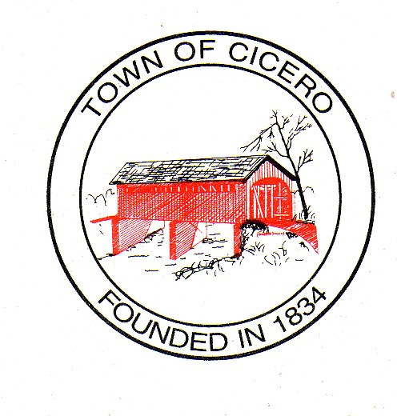
4 TOWN OF CICERO
TOWN COUNCIL MEETING AGENDA
Wednesday, May 17, 2016

At 7:00 PM

Call To Order:

Present: Brett Foster Absent:
Chad Amos
Chris Lutz
Rusty Miller
Craig Penwell

Declare a quorum present.

Others Present: Jan Unger, Clerk Treasurer
Charlie Cambre, Park Superintendent
Pat Comer, Street & Utilities Director
Dave Hildebrand, Police Chief
Lance Overholser, Fire Chief
Paul Munoz, Cicero/Jackson Township Plan Commission Director
Aaron Culp, Town Attorney
Keith Bryant, Town Engineer
Paul Utterback, Storm Water Management Board President

Approval of Agenda:

Approval of Prior Minutes:
Town Council Executive Session, May 4, 2016, 6:00 PM -
Town Council Meeting Minutes, May 4, 2016, 7:00 PM -

Approval of Claims:

Petitions by Citizens:

President’s Report:
Presentation of Award

Council Committee Reports:
- Events Committee –
- OTC – Pocket Park

Legal Counsel Report- Aaron Culp:

Cicero/Jackson Township Plan Commission Report-Mr. Strong.

Town Engineer Report-Mr. Keith Bryant –

Old Business:

Council To Consider Moving Forward With The OCRA Grant Facades For 2017.

Discussion On Capital Project Priority List.

Council To Consider Company For The Town’s Financial Consultant For Capital Planning.

New Business

Council To Consider Proceeding With RFP’s For Appropriated Street Paving.

Council To Consider Approving Clerk Treasurer Proceeding With An Additional Appropriation For The One-time Special LOIT Distribution For Roads.

Council To Consider Resolution 05-17-2016-1 Transfer Of Funds For Fire Department. (Additional Appropriation completed earlier this year went into Fire Equipment. Have a special line for Turn-out Gear and this is what is being replaced.)

Miscellaneous

Comments By Citizens

Signatures on Official Documents!

Motion To Adjourn:

The Next Cicero Town Council Meeting will be on, June 7, 2016, at 7:00 PM at the Cicero Town Hall.

